The Totally Awesome Report on Warhammer Statistics

To begin with, let's get a little background. Warhammer is a tabletop miniatures game about two armies going head to head. There are 3 variations of warhammer, Warhammer 40K(the most popular), Warhammer Age of Sigmar(AoS)(the best), and Warhammer The Old World(they killed this one and recently brought it back, probably should have stayed dead). The game is played mostly using D6s. You roll various amounts of D6s for attacks, to charge, for some objectives, pretty much anything. While destroying the opponent’s army is generally a good plan, the game is won or lost based on victory points. You get these points by capturing the main objectives on the table, or completing secondary objectives. Technically the secondary objectives are chosen at the beginning of the game, but in past editions there was a little secondary deck you could randomly choose from each round. Not only was this more fun, but it also allows us to do some ‘deck of cards’ stats, so we are going to assume the game is being played using 9th edition rules. Does that mean anything to you? Probably not. Does it matter? No. Does any of this need to be said? No but I did anyway (I UNDERSTAND THIS IS NOT PROFESSIONAL AND I WOULD NOT INCLUDE THIS IN PROFESSIONAL WORK. PLEASE DON'T TAKE MY POINTS, I NEED THEM TO GRADUATE). Now with the basic premise out of the way, let's get into some stats!

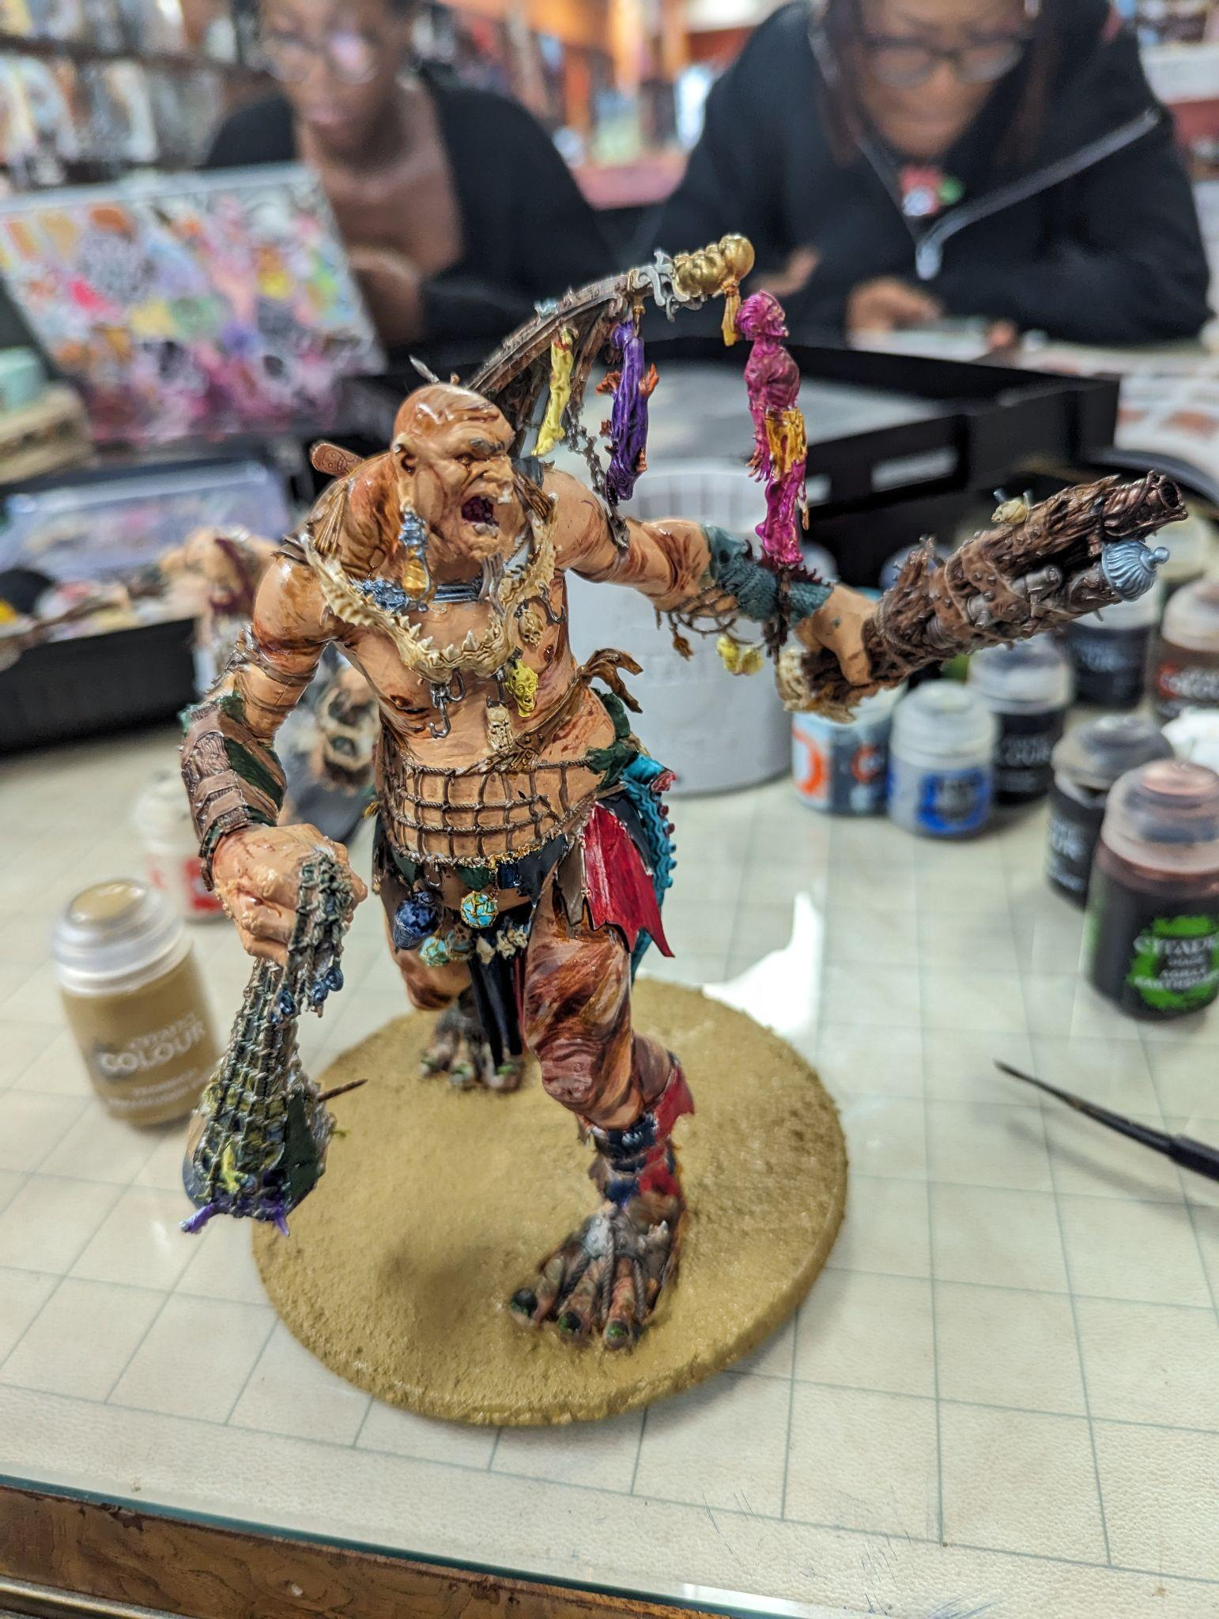<Mini for Age of Simar that I built and painted

(You have to build and {usually} paint each model you buy. Irrelevant, but I wanted to include)

# Chapter 1: The basics

To begin with we have chapter one, which is pretty easy. Mean, median, mode, variance, and standard deviation. I always want to abbreviate standard deviation to STD, but I won’t for obvious reasons. (Side note: the faction Slaves to Darkness have a bad time with this as well). When playing warhammer, knowing the probability of certain events can make a huge difference when making choices, and give a player a large advantage. So let's do some basic stats:

* **Mean:**

  + Now, that complicated looking equation pretty much just comes down to: add all the possibilities and divide the number of possibilities. For example, A die has 6 sides. The average roll is (1+2+3+4+5+6) = 21/6 = 3.5. Now, of course you can’t roll a 3.5 on a D6. The mean isn’t showing what you are most likely to roll, but instead the average result. A little odd to think about, but trust me, the math maths. Now if we are rolling two dice, the average is going to be 7. THIS IS VERY IMPORTANT FOR THE GAME!!! When you charge, you roll 2D6. The result is how far you get to move, and at the end of the move, you have to be within 3in of the enemy unit. Knowing the average charge is 7in helps make informed decisions when playing
* **Variance:**

  + Again, a crazy looking equation, but it’s not that bad! Again, looking at the variance on a balanced D6, we have : . This is generally how far the numbers get from the mean… which makes sense. I mean it's a D6, I would hope it could be 1-6. When looking at two dice, since each result is independent we can just add the variance to get 5.84.
* **Standard Deviation**
  + This is just the square root of the variance. . This is how far you usually deviate from the mean. This also makes sense, again it’s a die. That being said it is good to know that you most likely will get 2-5 on a die. Standard deviation, similar to variance, can just be multiplied for 2 dice, giving us a standard deviation of 3.42. This is also good to know when charging, as you are mostly likely to get somewhere in the range of 4-10 range.

So how is this useful? Well, this can help greatly when making informed decisions when playing warhammer. When you are going to move your unit with plans to charge, as long as you are within 7in of the enemy, you are likely to make the charge. If you have an attack that hits on a 5+, you will probably miss. This all may seem trivial(though this first section kind of is), these are very important things to keep in mind. Trust me, I have played against people who don't understand these base concepts, and it is hard to not just stomp them.

# Chapter 2: A New Set of Problems

Now, how do we apply set theory to Warhammer? Permutations and combinations are easy with the dice, but what about general set stuffs? Well, to that end we can use tournaments! Tournaments are where various players come together to play competitive games of Warhammer. We can look at these players and separate them into various sets to fit our needs! For this group of sets operations, we’ll assume there is an AoS tournament taking place. Each player’s army is a part of some overarching ‘Grand Alliances’; Order, Chaos, Death, Destruction. Within those grand alliances, there are multiple different factions that can be played.

We can represent this with an ordered pair representing(Grand Alliance, Faction). The tournament has 10 players, tournament A. This tournament consists of: {(Order, Stormcast Eternals), (Order, Lumineth Realm Lords), (Chaos, Disciples of Tzeentch), (Destruction, Orks), (Destruction, Gargants), (Death, Flesh Eater Courts), (Order, Fyre Slayers), (Chaos, Maggotkin of Nurgle), (Order, Lumineth Realm Lords), (Chaos, Hedionites of Slaanesh)}.

We will then say there is another tournament, this time with 7 players, tournament B. This tournament consisted of: {(Chaos, Skaven), (Order, Sylvaneth), (Order, Lumineth Realm Lords), (Chaos, Slaves to Darkness), (Death, Flesh Eater Courts), (Death, Ossiarch Bone Reapers), (Chaos, Skaven)}. Now, let's do some set stuff!

* **Sets:**
  + A∩B = Intersection of sets A and B (What’s in both)(A AND B)
    - This would be the set {(Order, Lumineth Realm Lords), (Death, Flesh Eater Courts)}
      * I realize now that there's not a lot of overlap, but still!
  + A∪B = Union of subsets A and B (Add them together) (A AND/OR B)
    - This would be the set {(Order, Stormcast Eternals), (Order, Lumineth Realm Lords), (Chaos, Disciples of Tzeentch), (Destruction, Orks), (Destruction, Gargants), (Death, Flesh Eater Courts), (Order, Fyre Slayers), (Chaos, Maggotkin of Nurgle), (Chaos, Hedionites of Slaanesh), (Chaos, Skaven), (Order, Sylvaneth), (Chaos, Slaves to Darkness), (Death, Ossiarch Bone Reapers)}
  + A’ = Complement of subset A (Everything not in the subset)
    - {(Chaos, Skaven), (Order, Sylvaneth), (Chaos, Slaves to Darkness), (Death, Ossiarch Bone Reapers)}
* **Permutation:**
  + An ordered arrangement of r distinct objects is called a permutation. The number of ways of ordering n distinct objects (total) taken r at a time(how many) is denoted P(n/r), and by the multiplication rule we have that
  + So, let's look at this: let's say that in the first tournament, each order player gets assigned another order player as an opponent. Of the 5 tables at the tournament, that would mean 2 tables are (Order, Order), with the rest not really mattering.
    - = 1037836800
    - That is a very low chance. If something like that were to happen, you could probably call shenanigans!
* **Combination:**
  + The number of combinations of n objects taken r at a time is the number of subsets, each of size r, that can be formed from the n objects.
  + Where
  + If we look at both tournaments, and grab 4 armies at random, what are the chances they are all from the Order grand alliance?
    - Number of elements in
    - P(A) = A/S = 30/57120 = .0005252100840336134453781512605042 = .052521%
* **Probability of A Given B:**
  + P()=
  + So, let's say we pick a random faction from those participating in one of the events at random. Given it is from the Grand Alliance Order, what are the chances it is Lumineth Realm Lords?
    - S = 17 = total outcomes
    - A = 6 = total order players
    - B = 3 = Lumineth Realm Lords players
    - = {3}
    - P(A) = 6/17 =35%, P(B) = 3/17 = 18%, P() = 1/2
    - P(A|B) = =
  + I messed up here, conceptually this is always weird. Given they chose the order, it should be a 50% chance to pick LRL . I don’t get it.

What did we learn? Well… If you are playing Order and there are 9 other players and 3 others are Order, it is unlikely to have 2 Order v. Order pairings in the same round. Honestly this was hard for me to get a useful reasoning out of. Honestly an odd section as a whole. Needed for the rest of the class, but odd none the less.

# Chapter 3: Let’s Discreetly Add Some Variable Probability

Now here we start to get fancy with it. From here, we are gonna start using actual statistics from the game! For this, we are going to look at the popularity of all the factions in the game. This is going to be fun for me, because I always love to see what everyone is playing, and what are the chances you see someone else playing your faction. I know a guy who went to a major tournament, and only saw 1 other player playing his faction. So lets see what we got! There are 28 factions split amongst the 4 grand alliances.

1. Order (44.2%)
   1. Cities of Sigmar (2.82%)
   2. Daughters of Khaine (5.73%)
   3. Fyreslayers (3.73%)
   4. Idoneth Deepkin (4.04%)
   5. Kharadron Overlords (2.57%)
   6. Lumineth Realm-Lords (2.57%)
   7. Seraphon (5.68%)
   8. Stormcast Eternals (9.82%)
   9. Sylvaneth (7.24%)
2. Death (15.88%)
   1. Flesh-Eater Courts (2.50%)
   2. Nighthaunt (6.83%)
   3. Ossiarch Bonereapers (1.88%)
   4. Soulblight Gravelords (4.67%)
3. Chaos (22.64%)
   1. Beasts of Chaos (2.77%)
   2. Blades of Khorne (2.43%)
   3. Disciples of Tzeentch (1.03%)
   4. Hedonites of Slaanesh (1.59%)
   5. Maggotkin of Nurgle (6.04%)
   6. Skaven (5.53%)
   7. Slaves to Darkness (3.25%)
      1. Standard (2.43%)
      2. Legion of The First Prince (.82%)
4. Destruction(17.28%)
   1. Gloomspite Gitz (2.69)
   2. Ogor Mawtribes (2.41%)
   3. Orruk Warclans(8.80%)
      1. Krule Boyz (1.85%)
      2. Ironjawz (4.48%)
      3. Bone Splitterz (1.35%)
      4. Big Waaagh! (1.20%)
   4. Sons of Behemat (3.30%)

* **Binomial Distribution**
  + So, let’s say we are playing in a massive tournament, with the above stats. We played a total of 8 rounds. Let’s say we are playing a faction that stomps chaos, and we want to guarantee win at least half of our games. What are the chances we go up against at least 4 Chaos factions?
  + Pmf of a Binomial Distribution:
    - * But in this case, we need the probability of at least 4. So our equation will look like :

Result: .00000000000837%

Conclusion? Bring a good army, and don’t rely on an anti-Chaos gimmick

A friend of mine tried this, it did not go well

* + - * + **Expected**

8*.2264 = 1.8112

In this scenario, this is the average number of Chaos armies we would go against. So on average we would see 1-2, must less then the hopeful 4+

* + - * + **Variance**

8*.2264*.7736 = 1.4

This shows that most of the time, we are only going have 1-2 chaos armies we go against. There is going to be very little *variance* in that number.

* + - * + **Standard Deviation**

=1.18

This shows how spread out the likely number of chaos armies we are going to go against with respect to the mean. I.E, it isn’t going to deviate from the mean very much at all.

* **Geometric Distribution**
  + So, let's look at that tournament again. We are going to see the chances of that one buddy of mine seeing that other Flesh Eater Courts player in his third match (which he did). This is going to assume that all pairings are random, otherwise things get funky with the win rates. Also, people can play the same person twice. Anywho, lets go!
  + **PMF=**
    - * Essentially what is the probability of y failures followed by 1 success
    - That's pretty low! Honestly it's shocking they played against each other at all! Matter of fact…
    - By finding the probability for y = {1, 2, 3, 4, 5, 6, 7, 8}, we can find that there was only a 15.834% chance of playing against another Flesh Eater Court player at all!
      * Of course these numbers change the more actual numbers on the tournament we have, but still fun to find an approximate number!
  + **Expected**
    - * That means on average, it would take about 40 games to play against another Flesh Eater Courts player!
  + **Variance**
    - * This shows there could be a fair amount of variance when we see the first Flesh Eater Courts player!
  + **Standard Deviation**
    - * This shows that most of the time, we will see the first player somewhere within the first 80 players we go against. This is still a huge gap!
* **Hypergeometric Distribution**
  + For this one, we are going to say that we have 100 players. 44 playing Order, 16 playing Death, 23 playing Chaos, and 17 playing Destruction. If we grab 8 different players randomly, what are the chances that we get exactly 4 order players?
  + **PMF:**
    - * That’s really not a bad percentage! It may seem like it should be higher given that about half the players are from order. One would that that therefore our set should also have about half order. We have to keep in mind, there are ALLOT of possibilities. As we look into it, we can find that indeed, order will usually make up a little less than half the group!
  + **Expected**
    - * This shows that on average, we would have 3.5 order players in our group of 8 players. As stated before, this is just below half the group!
  + **Variance**
    - * This tells us that we will almost always have at least 1 Order player, though rarely more than 5
  + **Standard Deviation**
    - * This shows that most of the time, we will see 2-4 Order players in our pod of 8
* **Negative Binomial Probability Distribution**
  + For this one, we will go back to the Flesh Eater Courts player. Lets say that not only does he play against another Flesh Eater Courts player once, but that instead he plays against one 3 times, with the third encounter being in his final round?
  + **PMF:**
    - * Low, but honestly not nearly as low as I would have thought!
        + **Expected**

This shows that, on average, it would take 120 games to play against the third Flesh Eater Courts player! That is more games than anyone has time for. That is crazy. This also makes sense because we found 40 games on average to get the first FEC player. This is looking for the third game, so the math is mathing!

* + - * + **Variance**

This is showing that there is a crazy amount of variance when we see our third FEC player. Hey, at least we know it probably won’t be on our 4801st game!

* + - * + **Standard Deviation**

This is just showing that most of the time, it’ll be between our 52nd and 188th game that we find our third FEC player.

* **Tchebysheff theorem**
  + So lets look at our geometric distribution. In that we learned that on average it would take about 40 games to find another FEC player, but what are the chances that we find them within the range of game 35-45? Well to do that we can use Tchebysheff’s theorem! Through that, we can find that about 64% of the time, you will encounter your first FEC player between game 35 and game 45!

What did we learn? Well in this section, it is really interesting to be able to break down playmates and find the probability of certain outcomes. At the very least, if you hate one specific faction, you could try and find the likelihood that you have to play against them at an upcoming event. If you look at some armies and split them into general themes, you can even find the likelihood you go up against one theme or another. A good example is adding together the play rates for things like Sons of Behemat, Ogors, Iron Jaws, Stormcast Eternals, and Fyreslayers. Then, if you look at the 8 rounds of a tournament, you can find out the likelihood you play against one of those armies any number of times. With that information, you can better tailor your army to be able to handle tough units, something all of those groups specialize in! Why bring something for fun when you can instead bring something mathematically correct!

# Chapter 4: These variables and distributions are continuous!

AKA: Uh-oh, calculus time

So, this is where I was unable to get my adderall. That means I lost focus a lot in class, and missed most of this and the next section. All of this is mostly going to be me trying to figure out each of the sections at 3:27am by just going through the book! Wish me luck! (note from future Nick, I got to Gamma probability and realized I was doomed.)[Oh my god I messed up so bad]

* **Uniform Probability**
  + So! Let's say that you are playing a game of AoS. This time you are playing against the Beasts of Chaos. They have an ability to show up in any part of the map that is secretly determined before the game. If we split the table into 9 equal pieces, and assume they have an equal chance of showing up in any one of the pieces, what is the probability that the Beasts of Chaos player shows up in their back three sections?
  + **Probability**
    - * I mean, this makes sense. When it comes to uniform probability, it is allot like the stuff we have dealt with already! Pretty easy stuff really
  + **Expected**
    - * This is just the average of the two values. I guess on average if the BoC player is in the back three, it’ll be 7.5? I dunno. This all seems like a complicated way of saying something straightforward.
  + **Variance**
    - * Its not going to variate allot. This is neither shocking, nor particularly interesting.
  + **Standard Deviation**
    - * Y’know, that is the most standard deviation I’ve seen. Like, if I were to ever deviate from the standard, I would want it to be like that.
* **Normal Probability Distribution**
  + Okay, this one I think I kind of get. Essentially, you can use this to find the likelihood something will fall in a particular area of a normal distribution. It’s like Tchebysheff’s, but its more customizable and only for normal distributions. Lets try it out. Lets say I run tournaments for 10 years, and track the number of people that come out. I find that I have a normal distribution of players attending my events! The average attendees I get at my event is 10, with a standard deviation of 5. I need at least 8 players to first the tournament. I am also considering capping the attendance at 12 players, to help things run smoothly. That percent of the distribution falls between 8 and 12 players?
  + **Probability**
    - .
      * If this were the case, then changing the tournament cap would lead to them only being able to fire 31% of their events! That’s less than a third! With this in mind, that would likely be an awful Idea, and instead they should consider expanding their viable player counts.
  + **Expected**
    - . Provided in the question
  + **Varianc**e
    - . Provided in the question
  + **Standard Deviation**
    - . Provided in the question
* **Gamma Probability Distribution**
  + Unfortunately, from here I am completely lost. I started at 3:27 and it is 4:53 now. I can't even figure out what kind of equation I am supposed to use. I’m just winging it and hoping I’m close. Anywho; Lets assume you have a game of warhammer that requires you to make a check that follows a gamma distribution. The time between checks follows a gamma distribution with a shape of 3 and a scale of 2 hours. What is the likelihood that you will have a check within the first 4 hours of playing?
  + **Density function**
    - * This shows that there is a low chance of you having to make the gamma distribution check within the first 4 hours. This makes sense, as I personally have never had to make a gamma distribution check in my games. Maybe that is a homebrew rule?
  + **Expected**
    - * This shows that on average, you wouldn’t get your first gamma distribution check until about 6 hours in. That also makes sense from my experience. Most of my games don’t go over 4 hours, so I wouldn’t hit that 6 hour sweet spot.
  + **Variance**
    - * Pretty big variance I’d say. I know I certainly wouldn’t want to play for 24 hours just to get to my first gamma distribution roll. That would be way too long… Though it does seem like a unique experience I must admit… Think I would get extra credit for succeeding a gamma distribution check?
  + **Standard Deviation**
    - * Waiting 2-10 hours is a lot more reasonable than waiting 24 hours. That being said I totally did end up getting a gamma distribution check, and passed. You can trust me, I am a sleep deprived college student trying to get a good enough grade to pass, I can't think of a more trustworthy individual :)
* **Beta Probability Distribution**
  + Okay, I did not actually make a gamma check. I lied. I am sorry. I couldn’t live with that on my conscience. That being said, I just learned of a totally awesome new check that I need to try, the Beta Probability check! Let me explain: If you get multiple people together in a warhammer game to chat and pray to the dice gods, you can manifest perfect dice rolls forever. The progress of this ritual is best tracked with a beta distribution!(Who woulda guessed). Now, this distribution happens to have shape parameters of . Lets find the probability that the ritual is at least 80% done after 3 hours of casting, I don't have all day after all!
    - More conscious Nick here. I just thought I could change this to be the time a warhammer game takes to finnish. Like, the amount of time a warhammer game takes to end falls on a beta distribution, what are the chances you are 80% of the way through your game at the 3 hour mark. Ah well, this is funnier.
  + **Density Function:**
    - * This shows that the ritual for the Beta Probability check is way too slow for me. I would totally lose interest 3 hours in, and then most likely ruin the spell for everyone involved. Even with a 65% chance to be MOSTLY done, I would be too bored.
  + **Expected**
    - * I don't know what this means. I do know that you can tell if a cranberry is ripe by if it bounces like a rubber ball. That's a true fact. Look it up.
        + Okay, less sleep deprived nick here. I am guessing that the expected is how done the ritual would be on average at this time. Still way too slow for me though.
  + **Variance**
    - * Yup. thats a number. I bet the standard deviation is gonna be the square root of this.
  + **Standard Deviation**
    - * I WAS RIGHT!

So, what can we learn from all this? Honestly I’m not sure. Maybe warhammer wasn’t the best choice for this topic? Maybe the problem is that I couldn’t pay attention and missed out on most of the last month of the class? Nah, probably the first thing.

# Chapter 5: Yeah, ya lost me.

Yeah, I got nothing. It’s 5:30 and I have to get ready for work in half an hour. I don't know these. I know they were covered in class, and they involve double integrals. Other than that, I got nothing. I am sorry.

* **Bivariate and Multivariate Probability Distribution**s
* **Marginal and Conditional Probability Distributions**
  + **Marginal Probability Function**
  + **Marginal Density Function**

# Conclusion:

So, clearly stats can help in allot of ways, especially when it comes to games. In games like Magic the gathering, knowing the likelihood of drawing any one card from your deck is a hallmark of top tier competitive play. For games like Warhammer, knowing how likely you are to hit and deal damage on any given attack is instrumental in deciding where to put your units. When building your army, knowing what your army can and can’t deal with is very important. Just as well, knowing what you are most likely going to be facing can help you make informed decisions about list building. When deciding whether you and your group could complete the Beta Distribution Ritual, knowing how done you likely are going to be at different times can help immensely in snack planning. Overall, understanding statistics and the various tools therein can help astronomically when preparing for your next Warhammer game!